The Backbone architecture description language

Backbone is an ADL that uses a UML2 profile. The restrictions in the profile, particularly related to part multiplicities, allow arbitrary visual nesting.

Definition model

Components
A component defines a software unit, which must explicitly express provided and required interfaces through ports. It can internally contain parts, which are instances of other components. The relationship between components and parts is similar to that of classes and objects in an object-oriented language. Components must not require or provide interfaces except through ports.
A component has attributes and ports. Components are either composite or leaf. Composite components may contain parts and connections, but leaf components do not. Composite components do not have any intrinsic behaviour – this must be implemented by delegating to parts. Only leaf components have intrinsic behaviour, which is implemented in a language such as Java. Leaves do not explicitly have to specify operations – it is assumed that they implement any interfaces that are provided via ports.
Parts are linked to other parts only via connectors.
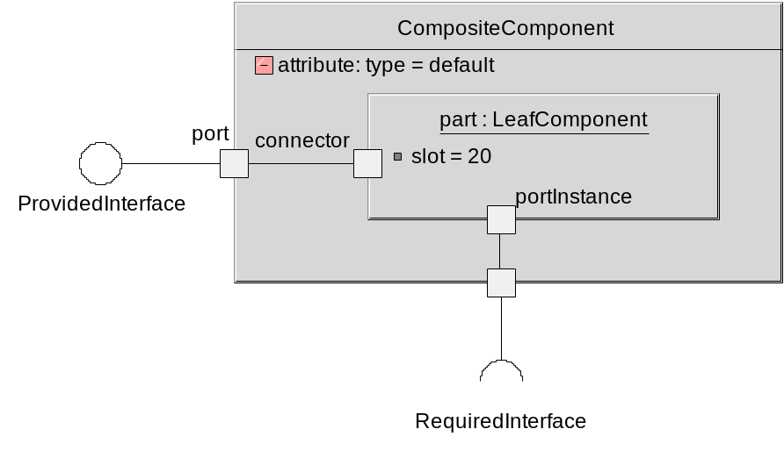
An attribute is a component variable and it is not visible externally. Parts have slots which must correspond to an attribute of the part’s type. A slot may define a value which override the attributes default value.
Connectors must connect two parts owned by the same composite, or must connect from a part to the enclosing composite. (When discussing connectors, it is always assumed that connectors actually join between ports and port instances) It is not possible to connect to a part directly from outside the composite. This must be done by connecting to the composite, and then the composite connecting to the part.
The configuration of parts within a composite indicates how the internals of the composite will be configured when it is first instantiated. This represents the starting condition of the component and the internal connections and parts can subsequently be altered by creation and deletion constructs.
A component is never allowed to directly expose parts via parameters of interfaces. A component can be regarded as a black box, which provides and requires services. For rules regarding what can and can’t be passed over service level interfaces, see [White-Box versus Black-Box].

Interfaces
An interface specifies a set of operations that a component provides or requires. Each operation is known by a name (with a single implied set of parameters). An interface can be either asynchronous or synchronous. Synchronous operations have an implied return message, which has the same name. The return message must be shown on a sequence diagram for synchronous calls, but is implicit in the operation specification.
Asynchronous interfaces have an arrow in the graphical representation.
IAsynchronous
operation()
ISynchronous
operation()

Operation signatures have the following form:
operationName(param1: Param1Type, …) [:returnType1, returnType2, …]
All operation parameters are “in” parameters. Asynchronous operations must specify a void return type. No default return values are allowed. No two operations in the same interface may share the same name.

Ports
Components define ports. These have a name, a multiplicity and provide and/or require a fixed set of interfaces. At least one provided or required interface must be supported.
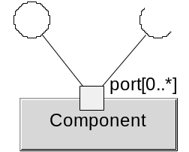
Components are able to detect if particular ports are bound, and deal with this accordingly. Optional ports with required interfaces [0..1] must be handled in this way.
The multiplicity of a port is shown in [] after the name. If a multiplicity is not shown, it is assumed to be [1].
Only public ports are allowed. Ports can be elided to look as if they aren’t there, in order to visually simplify the diagram. This should not be confusing, as long as it is realised that ports are always present even if they are visually elided.
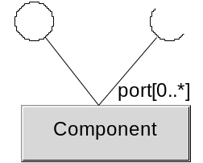
Port instances can be identified through a PortID. Each port instance is given a unique ID when it is created, and this will remain even though other instances relating to the same port are created and deleted. Note, however, that the index of the port will change as instances are created and deleted. A port with multiplicity >1 implies an ordered collection of port instances.

Parts
A part is an instance of a component, and that component is known as the type of the part. Parts represent instances that live within an enclosing component, which owns them. Parts are shown as nested inside the enclosing component with connections back to ports on the component boundary, or connections back to another part which is eventually connected back to the component boundary. Parts cannot be shared between enclosing components. Parts are constrained to have a multiplicity of [0..1] or [1]. Parts with a multiplicity of [1] can never be deleted. The multiplicity of a part is not shown visually.
A part can optionally have a name, which must be unique within the scope of the enclosing component.
Parts have slots which have values. Slots represent the actual attribute values, corresponding to the attributes of the type. If a slot is not specified for an attribute, the slot gets the attribute’s default value. To not specify the slot for an attribute without a default value is an error.
Parts have port instances, which correspond to instances of the ports of the type. Port instances may either be connected to other port instances, or to a port on the boundary of the component. Graphically a part is shown as a box. The name is followed by a “:” and then the component type name. The text is underlined, which visually differentiates it from a component.
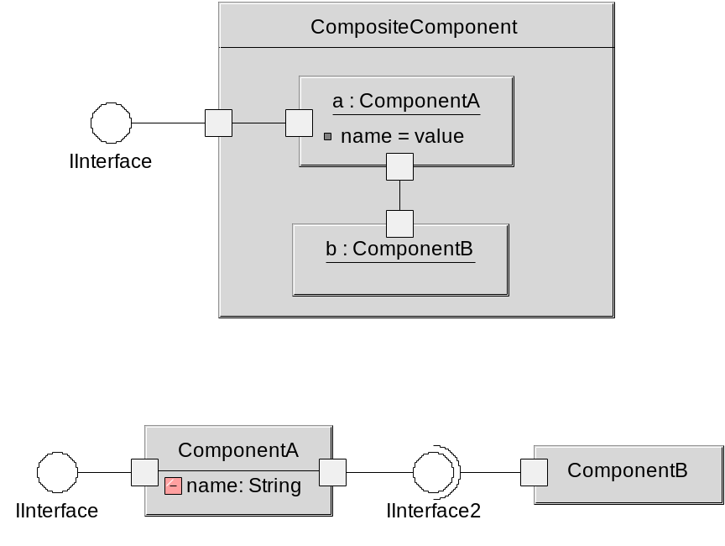
The component types for the part are defined at the bottom of the diagram. The components looks like they are directly connected but they are not. This is a way of simply showing that they provide / require the same interface, not that they have a direct connection. The topmost composite component connects the two parts of the components together.
Parts in a component represent the starting point of the configuration. Through creation and deletion of parts, the final configuration may be very different.

Visual Nesting of Parts
Parts can be visually nested to an arbitrary depth within a component. This allows a component definition to function as a form of hierarchy graph. jUMbLe will allow expansion and contraction of the insides of components and parts to allow for exploration of the component hierarchy of a system.
Consider the example of a web browser component. A black box view shows only the external interfaces:
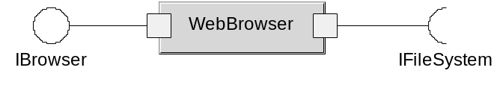
Expanding this to one level shows that internally, it is made up of a renderer and a protocol engine. This is a white-box level 1 view.
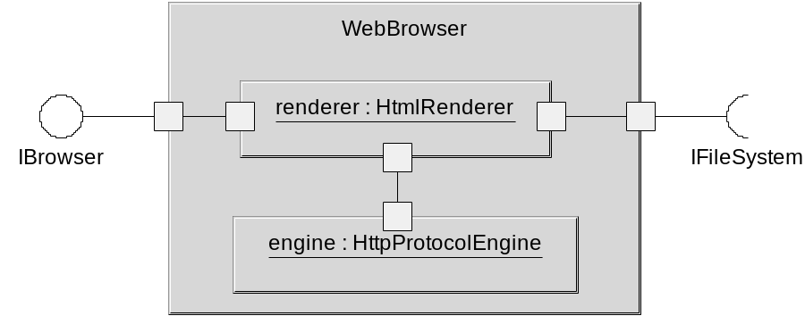
Expanding out the renderer shows further detail:
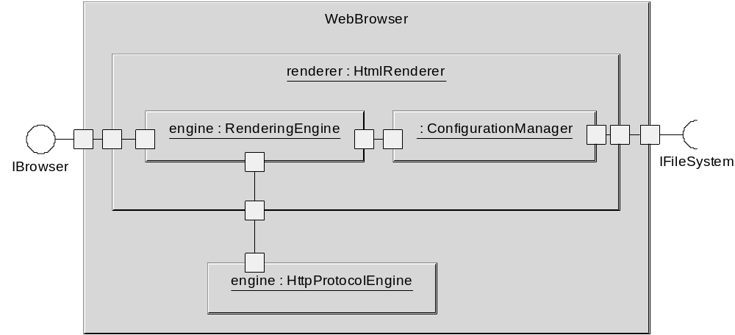

Nesting is supported to an arbitrary level. This is possible due to the UML2 custom profile, which places restrictions on part multiplicities.

Environment Attributes and Slots
An environment attribute is mapped to the enclosing component’s attribute of the same name. An environment attribute has a type which must match the enclosing component’s attribute. Visually this is shown in a component definition as a hollow box.
This provides a controlled way for a composite component to have state which is visible to (and shared with) owned parts. In the model below, EnclosingComponent::name and InnerComponent::name are effectively the same variable. Changes to one will affect the other, including assignment. Note that this is not a simple alias.
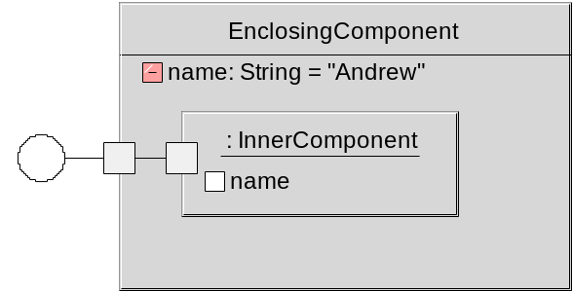

Multiple levels of sharing are possible:
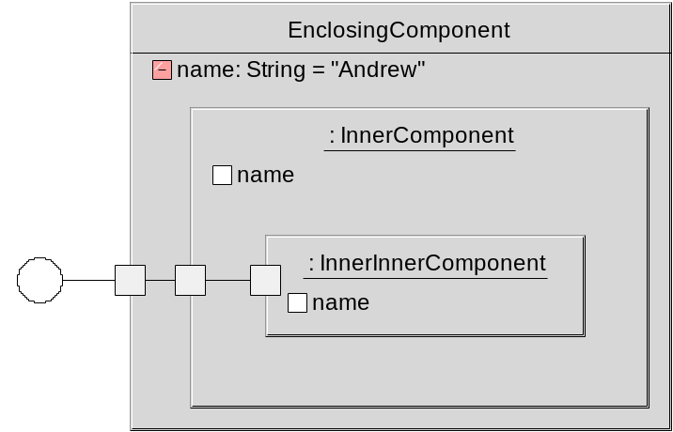

An environment slot must not have a value. Note that an environment variable prevents using a component as a part inside another component which does not have a variable of the same name and type.
In the above example, if InnerComponent did not declare a “name” environment variable, then it would not be possible for InnerInnerComponent to declare one.
If the enclosing component and part define the same attribute, then these are completely separate.
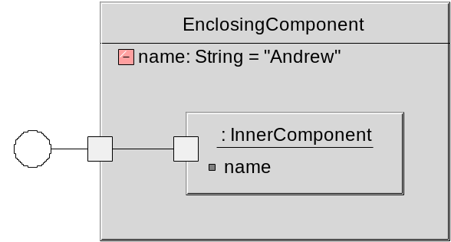

In this diagram, EnclosingComponent::name and InnerComponent::name are completely independent.
Environment attributes and slots are conceptually equivalent to a connection between the component and its parts where the enclosing component provides an interface with setVar() and getVar(). The part with an environment slot requires this interface and can set and get the shared variable.

Connections
A connection has two connector ends. Each end has a index which indicates how it is connected to the port or port instance. If an end has no index, it is assumed to cover the entire multiplicity of the port it is connected to.
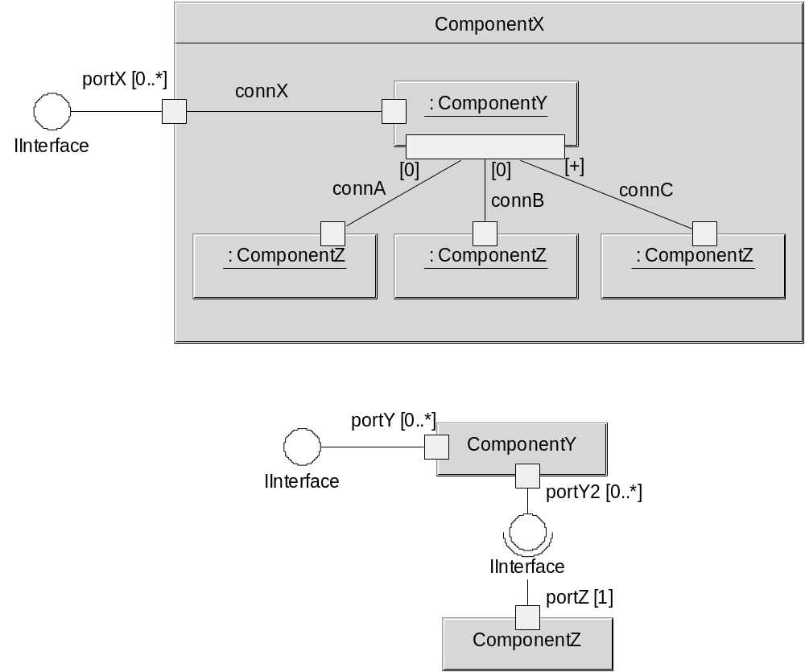
In the diagram above, there are 4 connectors:
- connX
This has no specified indexes, and as such forms a delegation connector from portX to the port instance portY. This means that any external client connected to portX[1], for instance, will in turn be implicitly connected to portY[1]. The creation and removal of port instances for portY are handled automatically.
- connA and connB
These are both connected to portY2[0]. The index will be created on connection.
- connC
This is connected to a newly created port instance for portY2. An index will be assigned upon connection. Note that if another connection also specified [+], it would get a separate port instance from connC.
Note that the many connectors can reference a port of multiplicity [1], as long as that port simply provides a service. This is why connA and connB can connect to the same port instance. Where a multiplicity [1] port requires interfaces, multiple connections to this port are an error.
It is an error to no have identical connection multiplicities for both ends on a connector. For instance, it would be illegal to a direct connection from portX of the enclosing component to portZ of a ComponentZ part, where no indexes were present. The problem is that one end maps onto the full multiplicity [0..*] of portX and the other end maps onto a single multiplicity [1] of portZ.
It is allowed for a connection to only match some of the interfaces specified for a port in two cases:
- if a port requires interfaces, the full set of connections must provide these, even though a single connection may not provide them all.
- if a port provides interfaces, a single connection can connect to any number of these.
For instance, the following is legal:
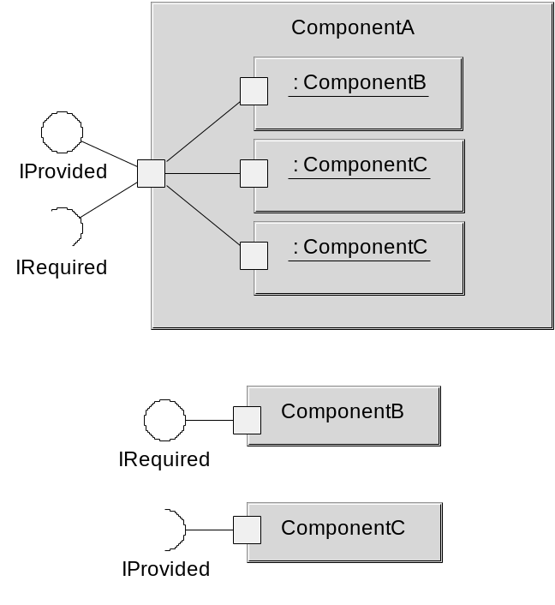
Note that optional ports [0..1] imply that if something is connected to the port, it exists, and all the interfaces must be satisfied through connections.
It is possible for a port to selectively implement parts of an interface, by specifying the names of the operations implemented after the port name in {}. The interface represents only a collection of operations, and it is possible to discriminate more finely at the port level. In the diagram below, the “a” part implements operation1, and the “b” part implements operation2.
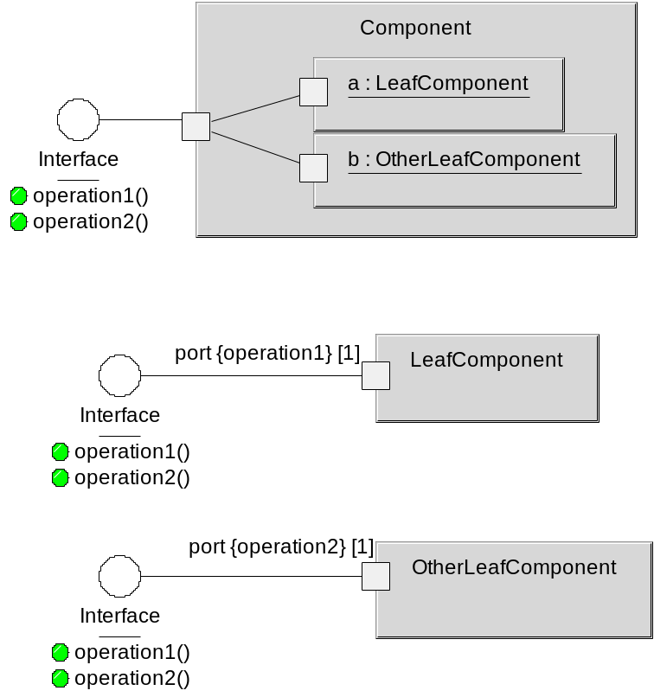
Further, as long as two interfaces have operations with the same names and parameters, they are considered to be equivalent and can be connected:
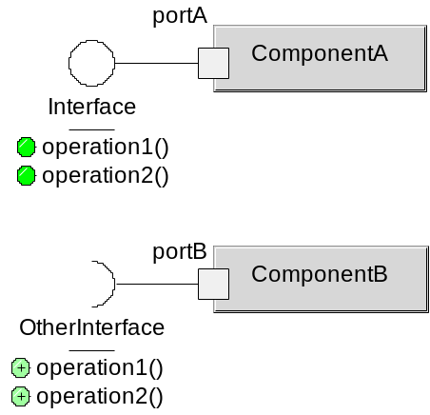
In the above diagram, a part of type ComponentA and a part of ComponentB can be connected, even though they implement different interfaces, as the operations are identical in both interfaces.

Creation and Deletion
Parts can only be created dynamically through an instantiator, and the instantiation operator. An instantiator is a component that instantiates the parts within as per normal, but allows some parts to be aliased to existing parts in another component.
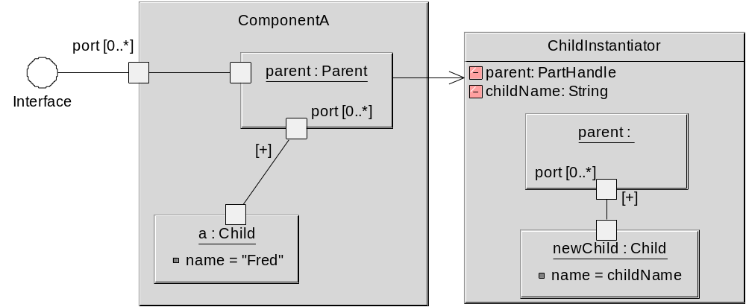

In the example above, an instance of Component will initially only contain a single child. However, the “parent” part may invoke the ChildInstantiator at any point to create a new child, linked to a new port instance of itself. Instantiators are like templates for construction of new parts that are linked into an existing arrangement of parts.
Several points are worth noting:
- “parent” and “childName” are passed in as parameters to the instantiator.
These values are given by parent when it calls the instantiator.
- “parent” is an alias for a part with a compatible port to link the newly created child to. Aliases can not specify a types, as the alias only shows a set of the concrete parts elements.
- Aliases must have the correct port names as the concrete part that the alias refers to.
- The alias need only show the elements that are relevant for the instantiation. The parent port is not shown as it is not needed.
Instantiators can specify links to potentially non-existent ports on the alias, as long as the other side of the connection has a [0..1] multiplicity. This can be used to effectively pick up possibly implemented “features” which are present on some components that are aliased, but not others.
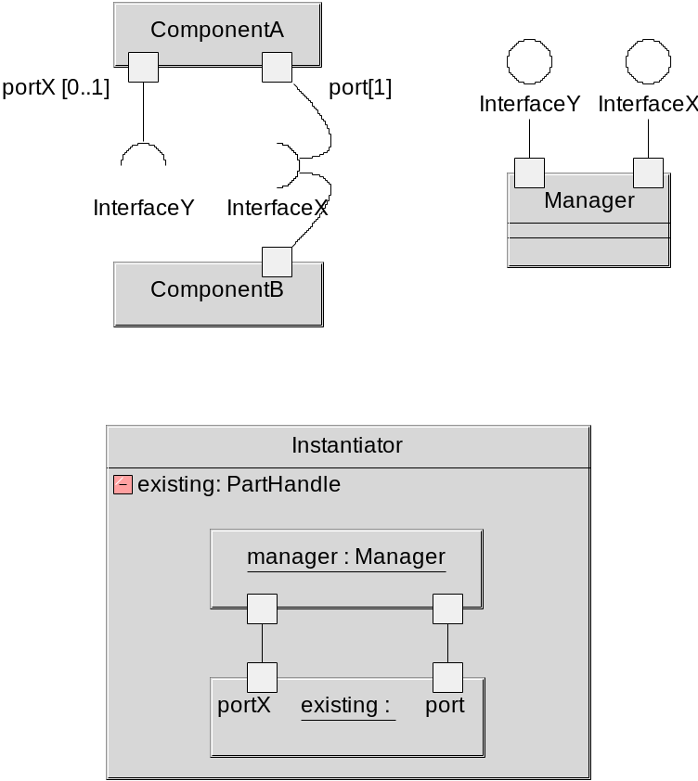
In the example above, the instantiator can be used to bind either a part of type ComponentA or ComponentB to a newly created manager. In the case of ComponentA, both connections will be made. In the case of ComponentB, only the “port” connection will be made. This is legal, as the unbound port for Manager is providing a service, and this can be legally left unbound. If an unbound port requires any interfaces, and the port is not optional [0..1] then an error results.
Deletion occurs by deleting a component, and tracing through the graph to delete all components which are implicated. Implicated components are those which require services of the initial deleted component, or those which are left orphaned by the any other deletions. It is illegal to delete a component which is eventually traceable back to a bound port on the enclosing component, unless that bound port can also be safely deleted.
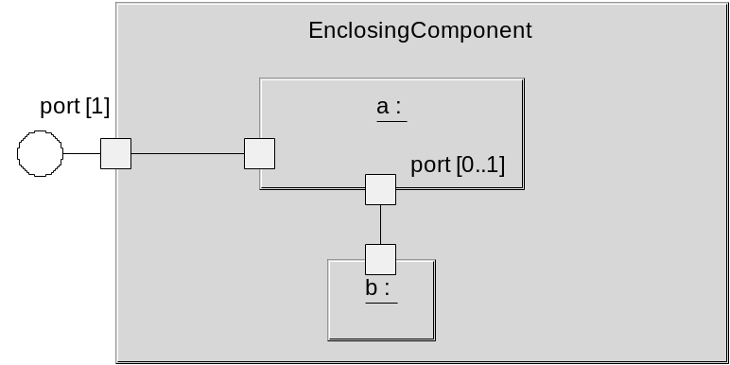

In the above diagram, it is legal to delete “b” as “a” can survive without it. However, it is illegal to delete “a” as it is bound to a port with [1] multiplicity on the enclosing component’s boundary.
Clearly, in some cases a significant amount of work is needed to compute the implication of the deletion of a set of components. Because component references cannot be passed outside of the enclosing component, only components inside the enclosing component can perform the deletion.
Note that it is possible to extract the PartHandle of any part that you are linked to, or can traverse to from other components you are linked to. This implies that creation and deletion of internal parts can only be performed by parts contained within the enclosing component.
A port with optional multiplicity [0..*], [0..1] etc, can refer to an instantiator. This is invoked when a new port instance is created.
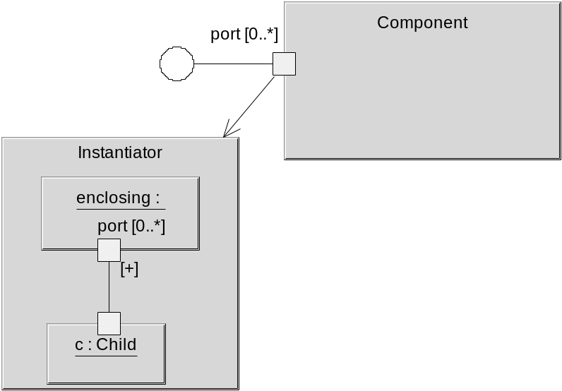

Behavioural Specification
The protocol of a component is specified by a sequence diagram which uses the ports as independent lifelines, and the component as another [uchital etc al]. This is a black-box protocol view which omits internal events.
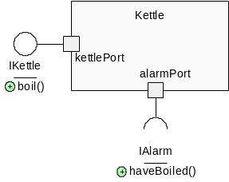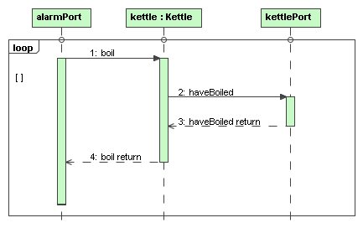
Prot_Kettle =
(kettlePort.receive.request.boil ->
alarmPort.send.request.soundAlarm ->
alarmPort.receive.response.soundAlarm ->
kettlePort.send.response.boil -> Prot_Kettle).
Translate to FSP
Only a subset of sequence diagram constructs are supported. “Loop” is supported, but with no guards or variables. “Opt” is supported, but not “par”. “Alt” is supported, but the condition must be unset, or refer to the presence of an optional port.
The aim is to support a protocol analysis of a component system to ensure that the connected parts match protocols correctly. This is done by constructing FSP expressions and looking for deadlock which indicates bad activity or no activity errors [plasil et al].
The black-box protocol can be checked with the white-box protocol, by analysing the LTS for both, and omitting internal events in the white-box case. The black-box protocol supports top-down development.
[Q: how does the black-box protocol handle redefinitions? Do we rule this out? Can we generate an FSP (and hence sequence diagram) for a black box, from the white-box FSP expression??? Is there anyway to simplify?]

The “Part in a Context” Principle
Certain characteristics of a part can only be determined once it has been placed into the context of a running system. Synchronisation primitives for a part are not needed, for example, if there is no chance of the multiple surrounding parts calling into the part at the same time.
Similarly, port + interface typing information can be propagated along a network of connected parts. Consider the following trivial example:
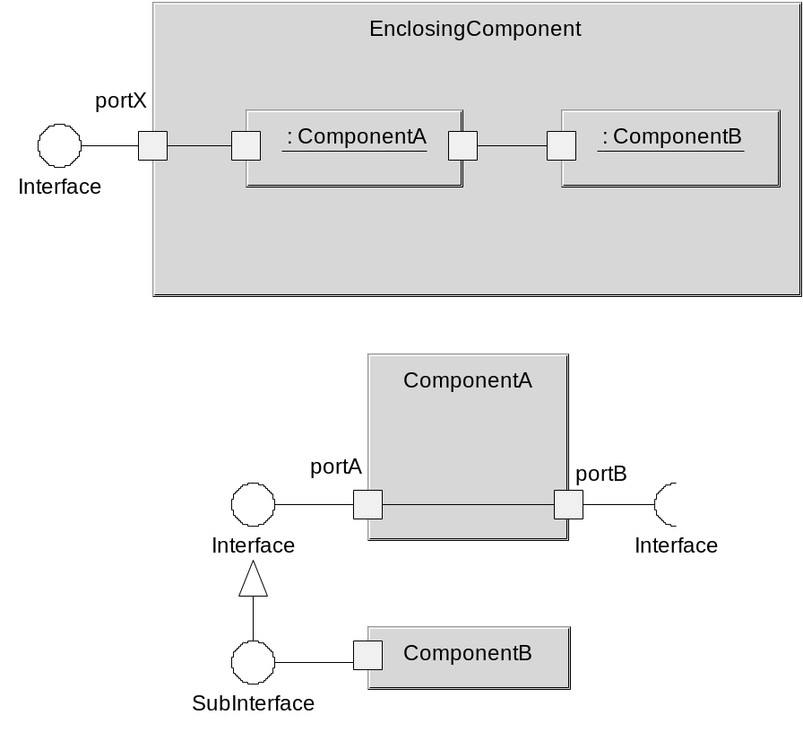
Note that SubInterface inherits from Interface. In this case, we know that portX is actually providing SubInterface, by following the connections.
In the case where ComponentA is a leaf, however, the port linking information is lost. A port type constraint is a pseudo-connection in a leaf component to show that internally the ports are related. This is shown as a dotted line with 2 arrows.
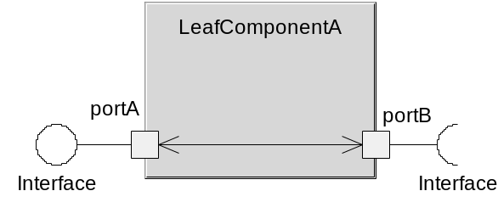
This has the same effect as a connector, but only for type propagation. It doesn’t imply or create a direct connection.

White-Box versus Black-Box
Components are black-boxes that only offer service interfaces to the outside world. A component may not pass to the outside a reference to a part nested inside it. A part may only legitimately acquire a reference to a part if it is directly linked to it, or by traversing its direct connections to the part.
There are three possible ways to refer to a part:
- Part interface reference
This is a reference to an interface of a part.
- Part handle
This is an opaque handle to a part, used only for instantiation and deletion.
- Part ID
This is an opaque identifier of a part, useful for passing out on service level interfaces so that when the ID is passed back, the owning component understands which part is being referred to.
Holding a part reference of any type will not prevent the part from being deleted. Whether a part can be deleted is computed purely from the links to that component.

Navigable Interfaces and Interface References
Interfaces can have operations that return a part interface reference to another part at the same level (or the same part). These are known as navigable interfaces, as they allow components with access to that part (via the interface) to navigate to other interfaces on the same part, or other parts in the same graph.
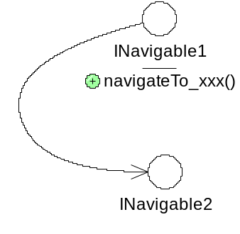
Graphically this is shown by a dependency between interfaces. Methods that return a part interface reference must be called navigateTo_ followed by an identifier.
NOTE: Only part interface references to parts at the same graph level of the part (including itself) can be returned from a navigable interface. This is to ensure that the outside world cannot see the internals of the component. Also, if no parts implement any navigable interfaces, the internal structure of the component obeys the Law of Demeter [ref].

Part Handles and IDs
A part can get a part handle as it is linked directly to that part, or can navigate to that part from direct links. A handle is opaque and is only used for instantiation and deletion. It is illegal to pass a handle as a parameter on an interface.
A part ID also identifies the part uniquely. Again, this is an opaque reference, and can be applied to a port to find the port that refers to the component. As this is only useful to the part which directly links to the part with the ID, it is safe to pass part IDs out via service level interfaces.

Redefinitions and White-Box Perspective
Redefinitions allow parts to be inserted into existing components, allowing for a white-box perspective.

TODO

Versioning and Evolution

Active Components
An active component is associated with a single independent thread.
{to do}

Graphical Modeling
Model element identity (xmiid)

Redefinition Perspective
Xmi id to allow things to have an identity even if the name is the same.
Identity of elements, even without a name…
Model Perspective
Packages and nested types…

Stereotypes
Visual styles (emulating parts of the UML)
Rules governing well-formedness (e.g. for state machines)

Patterns and Examples
As a compositional approach to system construction, Backbone should be able to support common compositional patterns. As a sanity check, the following patterns are examined:

State pattern
The object-oriented version allows a single state to be operational at any one time. Transitions between states occur by the state returning a new state instance (or identifier) back to the StateMachine as a return value. The StateMachine class holds the current state:
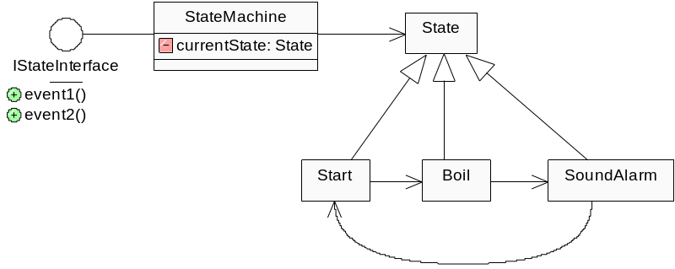
This can be implemented using a switch component in place of the StateMachine. The current state is held as a part ID. The switch is a reusable leaf component, which simply transmits any messages to the current state part.
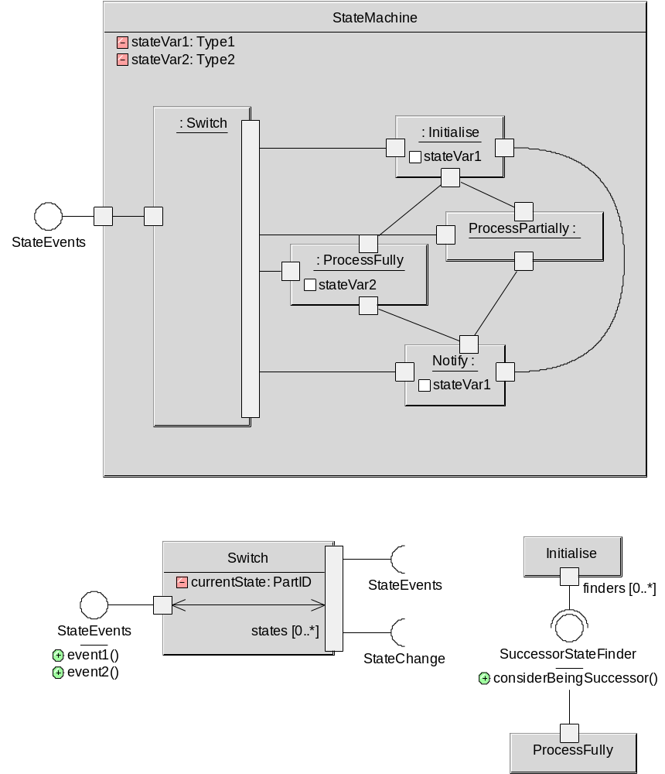
Clearly, each state part requires a link back to the switch part, so that the switch can transmit events to them. In addition, each part must connect to the StateChange interface, in order to tell the Switch if it becomes the current state.
Each state part needs a link to the possible successor states, via the SuccessorStateFinder interface. When the state has finished processing, and wishes to pass onto another state, it notifies the successor states. Note that the part itself only knows about the successor states due to the links. The successor states then decide independently whether they should actually become the successor, by examining the state variables, which are shared with the enclosing StateMachine component. If they are to be a successor, then they notify the switch via the StateChange interface.
It is important that the decision about whether a state is a successor belongs with the successor state, otherwise the existing state must encode logic relating to its successor.
We can visually omit the switch component, and draw the links between each state part as a directed line from requirer to provider. This is simply a visual simplification.
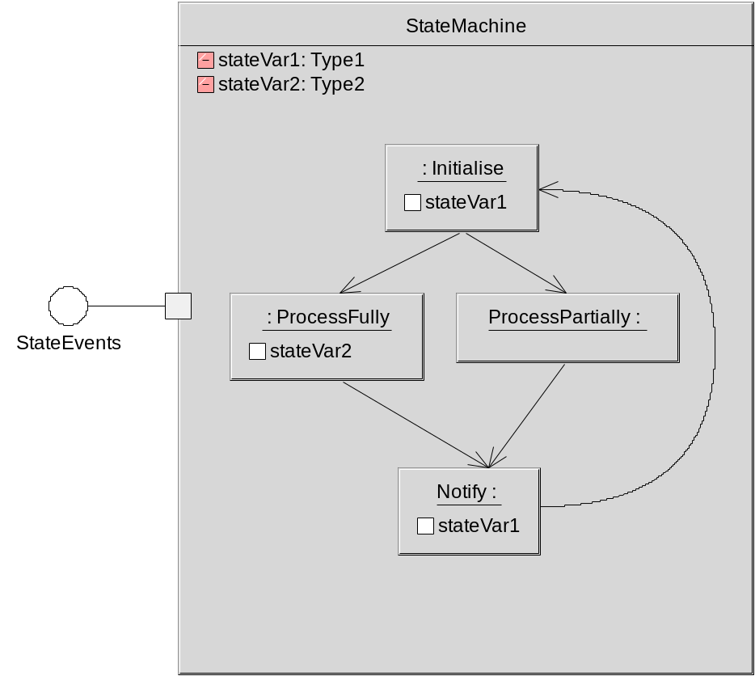
Finally, we can illustrate the intent by simply by altering the visual appearance of each of the state parts to make them look more like UML2 states:
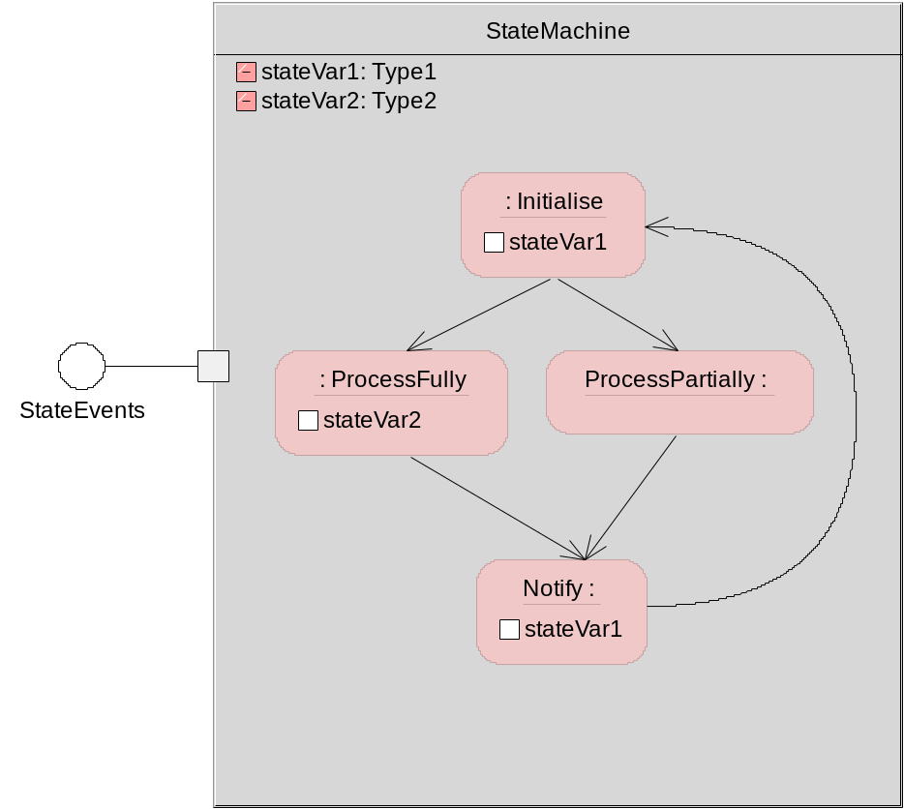
The state machine is using a structural approach, and as such it can work with redefinition.
The black box protocol of the StateMachine can be determined by analysing the links between the states, and factoring the protocol into a set or “loop”, “alt”, or “opt” segments. This translates into a simpler FSP production than if we had to compose the FSPs for each of the states.

TODO
Other patterns: factory (easy), singleton (removes need for), façade, decorator…
Junction boxes as a way to handle complex connections.
Toy example.

